Practical : 23

## Aim: Create a webpage to bind the user data from database into a gridview dynamically.

Home.aspx

<%@ Page Language="vb" AutoEventWireup="false" CodeBehind="Home.aspx.vb" Inherits="Practical_23.Home" %>

<!DOCTYPE html>

<html xmlns="http://www.w3.org/1999/xhtml">

<head runat="server">

<title></title>

</head>

<body>

<form id="form1" runat="server">

<div>

<asp:Button ID="btnFetch" runat="server" Text="Fetch Data" />

<br /><br />

<asp:GridView ID="gvData" runat="server" />

</div>

</form>

</body>

</html>

[Home.aspx.vb](http://Home.aspx.vb)

Public Class Home

Inherits System.Web.UI.Page

Protected Sub Page_Load(ByVal sender As Object, ByVal e As System.EventArgs) Handles Me.Load

End Sub

Protected Sub btnFetch_Click(sender As Object, e As EventArgs) Handles btnFetch.Click

Dim con As New SqlClient.SqlConnection("Data Source=(LocalDB)\MSSQLLocalDB;AttachDbFilename=C:\Users\ISHAN\Desktop\Databases\DummyData.mdf;Integrated Security=True;Connect Timeout=30")

Dim ad As New SqlClient.SqlDataAdapter("select * from Data", con)

Dim ds As New DataTable

con.Open()

ad.Fill(ds)

con.Close()

gvData.DataSource = ds

gvData.DataBind()

End Sub

End Class

Output :

Dummy Data In Database :

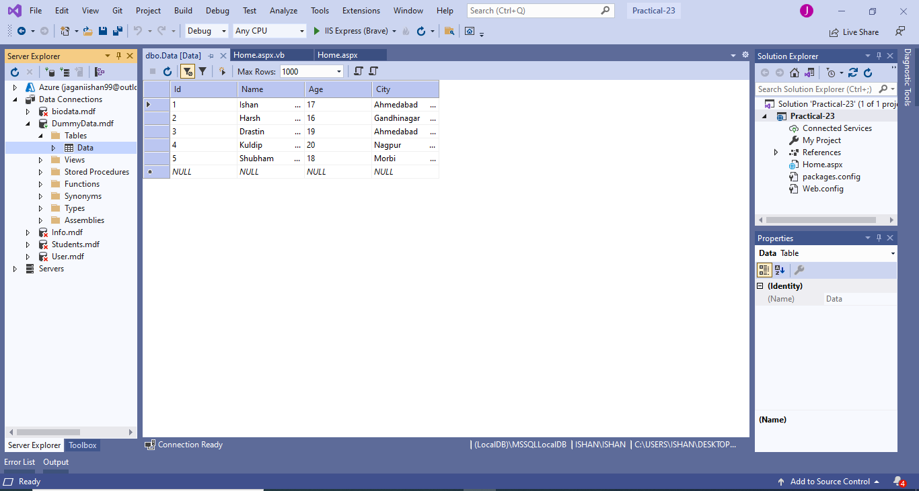



After Fetching Data :

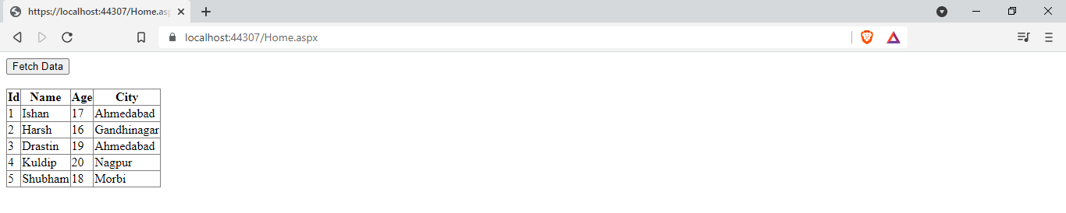

|  |  |  |  |
| --- | --- | --- | --- |
| Start Date | End/Sign Date | Faculty Sign | Remarks/Grade |
|  |  |  |  |